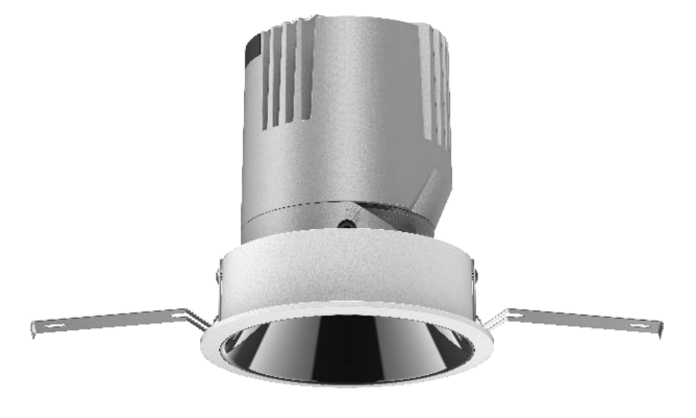**General Information**

Material: Aluminum

Fitting Colors: Matte White/ Matte Black

Rotation Angle (degree): 350

Tilting Angle (degree): 30

Track System: Not Applicable

IP Rating: 20

Working Temperature (°C): -5 - +32

Storage Temperature (°C): -20 - +50

**Product Dimensions and Cut-out Information**

Fitting Length (mm): Not Applicable Dimension:

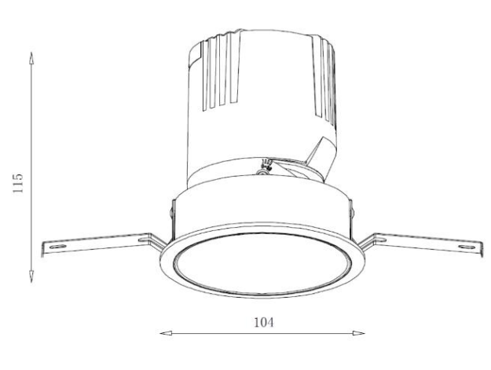Diameter (mm): 104

Height (mm): 115

Cut-out Dimension (mm): 95

False Ceiling Thickness (mm): 125

**Packing Information**

Packaging Type: Individual box

Quantity per carton: 30

CBM per carton: 0.084

Gross weight per carton (kgs): 15

**Lifespan**

Lifetime (hours): 50000

Luminous Flux after 50000hours (lm): LM80 Comply

**Light Technical Information**

|  |  |  |  |
| --- | --- | --- | --- |
| Color Temperature | CRI  (Ra) | System Lumen  (±5%) | Lumen per Watt  (±5%) |
| 2700 | 90 | 2094 | 86 |
| 3000 | 90 | 2228 | 91 |
| 4000 | 90 | 2369 | 97 |

LED Manufacturer: Luminus

LED Type: COB

LED Model: CXM-9 Gen6

Color Consistency: 3 Step Macadam Ellipse

Optic: Lens

Beam Angle (°): 28/45/55

**Electrical Information**

System Power (w): 24.4

Input Voltage (v) & Frequency: 220-240VAC 50/60Hz

Output Voltage (v): 31-37

Current (mA): 600

Driver: Tridonic Non-Dimmable Driver

Power Factor: 0.9

Efficiency (%): 86

Total Harmonic Distortion (%): <15

Ripple (%): <5

Dimmable: Triac Dimming – Upon Request

1-10V Dimming – Upon Request

Dali Dimming – Upon Request